Business Process Document

Coupa S2P Implementation – Supplier Management

Prepared by: SoluGrowth PSA
Date: 29 January 2026
Version: V1.3
Table of Contents
1 DOCUMENT MANAGEMENT AND APPROVAL 1
1.1 Document Details 2
1.2 Revision History 2
1.3 Abbreviations used in the Document 2
1.4 Legend/Key to interpret the process flowcharts 2
2 Purpose 3
3 Scope 4
4 Objectives 5
5 SUPPLIER INFORMATION MANAGEMENT OVERVIEW 6
5.1 Responsible Roles 7
6 Supplier onboarding process 7
6.1 Supplier Onboarding – external Registration 8
6.2 Supplier On-boarding – Internal Registration 10
6.3 Update Vendor – External 13
6.4 Update Vendor – Internal 15
6.5 Update Vendor – Status (Purchase block/ Payment Block/ Deactivate/ Reactivate) 17
6.6 6.6 SUPPLIER EXTEND 19
6.7 New Supplier Registration – One Time Vendor 21
7 Coupa SUPPLIER STATUS 23
8 KEY DECISIONS MADE AND EXCEPTIONS 24
9 GEOGRAPHICAL PROCESS DEVIATIONS 25
9.1 Process deviations 26
9.2 Information (Field REQUIRements) Deviations during onboarding 26
9.3 List of all attachments required across geographies 26
9.4 Language Requirements 26
10 UAT Scenarios 27
11 ACKNOWLEDGMENT AND SIGNATURE 29
Process Owners 30
11.1 Document Reviewers 30
11.2 Signatures 30

DOCUMENT MANAGEMENT AND APPROVAL

Document Details
Document Title | Business Process Document – Supplier Management
Department:
 | Name | Date | Signature
Prepared by: | Leroy Vieira | 18-Nov-2025
Reviewed by:
Document status | Draft ☒ Reviewing ☐ Approved ☐

Revision History
Version | Revision Date | Revised By | Description of Revision
1.1 | 18-Nov-2025 | Leroy Vieira | Initial draft version
1.2 | 06-Jan-2026 | Leroy Vieira | Updated the extension scenario
1.3 | 29-Jan-2026 | Leroy Vieira | Updated the One-Time Vendor Process

Abbreviations used in the Document
Abbreviations | Full Form
AP | Accounts Payable
CSP | Coupa Supplier Portal
DOA | Delegation of Authority
OTP | One Time Password
SAP | Systems, Applications, and Products
SIM | Supplier Information Management
OTV | One Time Vendor

Legend/Key to interpret the process flowcharts
Colour | Meaning
Black | General process flow: Represents the standard or Integration steps in the process.
Green | Logically correct flow/next step: Indicates the correct or intended progression in the process. Do not assume green always means "yes".
Red | Logically incorrect flow/next step: Identifies incorrect, non-compliant, or exception flows. Do not assume red always means "no".

Purpose
The purpose of this Business Process Document (BPD) is to define and document the end-to-end Supplier Management process within Coupa.
This document provides a standardized and controlled framework for onboarding, maintaining, and managing supplier information in Coupa, ensuring data accuracy, compliance, and alignment with organizational procurement and finance policies.
The BPD serves as a reference for business users, procurement teams, finance teams, and system administrators by clearly outlining the process flows, roles and responsibilities, approval requirements, system controls, and exception handling related to supplier lifecycle management.

Scope
The scope of this document covers the To-Be Supplier Management processes designed and configured in Coupa SIM for AECI and its applicable business units and geographies.
This BPD includes:
- Supplier onboarding through:
  - External supplier registration via Coupa Supplier Portal (CSP)
  - Internal supplier registration initiated by business users
- Supplier data maintenance processes, including:
  - External supplier updates via CSP
  - Internal supplier updates initiated by AECI users
- Supplier status management, including:
  - Purchase block
  - Payment block
  - Supplier deactivation and reactivation
- Approval workflows involving Procurement, Finance, General Accounting, and Master Data teams.
- Integration touchpoints between Coupa SIM and SAP for supplier creation, updates, and activation.
- Supplier status definitions in Coupa and CSP.
- Key decisions, exceptions, and geographical deviations impacting the supplier management process.
The document applies to all users involved in supplier lifecycle management.

Objectives
The objectives of this Business Process Document are to:
- Establish a standardized and controlled supplier onboarding and management process across all applicable AECI entities and geographies.
- Ensure data accuracy, completeness, and consistency of supplier master data across Coupa and SAP.
- Clearly define roles, responsibilities, and approval ownership throughout the supplier lifecycle
- Reduce manual intervention, duplication, and data inconsistencies by leveraging Coupa SIM workflows and system validations.
- Provide transparency and traceability of supplier requests, approvals, updates, and status changes.
- Support efficient collaboration between business users, suppliers, procurement, finance, and FSSC teams.
- Serve as a reference document for training, system adoption, future enhancements, and operational support.
By achieving these objectives, the BPD supports improved supplier data governance, streamlined onboarding, reduced operational risk, and effective utilization of the Coupa platform.

SUPPLIER INFORMATION MANAGEMENT OVERVIEW
This section is to outline the process and the design to be built into Coupa Test/Production instance for the Supplier Information Management (SIM). SIM helps manage supplier information metadata, process, and approvals. SIM streamlines requesting, approving, onboarding, and maintaining supplier information such as company registration document, Tax certifications as well as contact information.
Using forms, approval workflows, and notifications, SIM helps to ensure:
- Unvetted suppliers or services go through the proper approval channels.
- Information for all suppliers is accurate and current.
- Visibility to certifications and contact information.
- Multiple channels of managing information (e.g. paper forms, emails, phone calls, spreadsheets) are eliminated.
- Supplier participation.
Coupa SIM manages the Supplier creation and onboarding process. A Supplier will only be created in Coupa once they have completed the onboarding process.

Responsible Roles
Below is a detailed description of the steps carried out by responsible actors:
S. No. | Roles | Responsibility
1 | Requester | Trigger the  - New Supplier Request Form (Form1) for Supplier Onboarding (Internal/External),  - Supplier Update Form (Internal/External)  - Purchase/Payment Block Forms
2 | Procurement Team | - Review and approve the documents/data submitted by the requester and supplier in Form1 & Form 2 respectively.  - Fill in the Internal Section Data in Form 2 prior to approvals.
3 | Master Data Team | - Review and approve the New Supplier Request form triggered by requester.  - Review and approve all the update forms i.e. Internal/External Update, Purchase/Payment Block and Deactivate/Reactivate.  - Conduct Vendor Screening while onboarding the vendor.
4 | General Accounting Team | - Validating and approving the banking details of the vendor during onboarding process.
5 | AP/Procurement Team | - Trigger supplier status change requests.

Supplier onboarding process

Supplier Onboarding – external Registration
AECI’s supplier onboarding process is designed for engaging suppliers with whom the organization intends to conduct business with or procure goods and services. The requester can initiate the process by providing basic information, such as the supplier’s company name, email address etc. Following initiation, the request undergoes an internal approval workflow. Once approved, an invitation is sent to the supplier via email, prompting them to register with AECI and complete the required due diligence steps. This structured approach follows industry best practices for supplier onboarding within the Coupa platform.
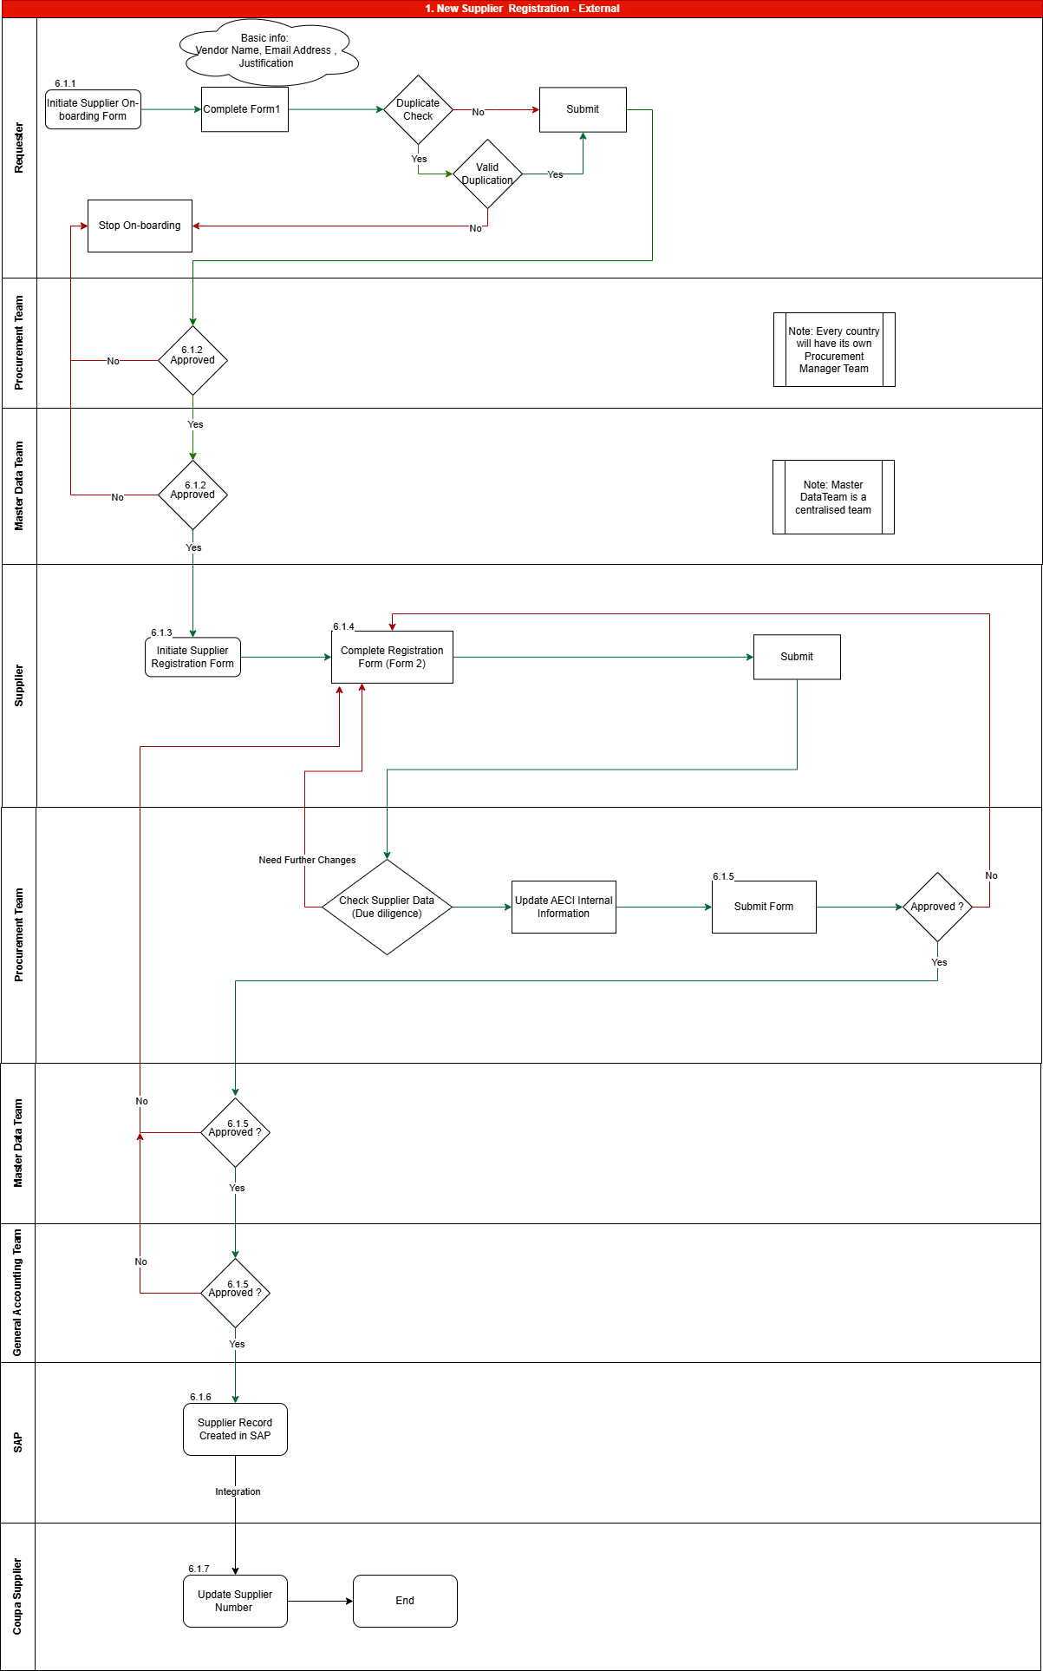
6.1 Supplier Onboarding Process Flow
Process Design Steps
The following section provides a comprehensive and detailed explanation of each step illustrated in the corresponding process diagram. This structured approach is intended to enhance clarity, support better understanding of the workflow, and offer meaningful context to stakeholders reviewing the process design. Each description aligns with the visual representation to ensure consistency and facilitate informed decision-making.
Activity ID | Activity Description | Detailed Description
6.1.1 | New Supplier Request | The external supplier onboarding process is initiated by the requester through a New Supplier Request form. The requester must provide all required supplier details in the form. Once submitted, the system automatically validates the information, checking for duplicate entries against Supplier Name,Email ID and Tax Details and highlighting any missing or incomplete fields for correction before final submission.
6.1.2 | Supplier Request Approvals | Once the New Supplier Request Form is submitted, the approval process is automatically triggered based on the predefined workflow, typically involving:  - Procurement Team  - Master Data Team  In case of rejection, the system prompts approvers to provide rejection comments. These comments are shared with the requester, enabling them to review the feedback and resubmit the request after making the necessary corrections.
6.1.3 | Coupa auto triggers the External Onboarding form | Once the New Supplier Request Form is approved, the system automatically triggers the External Onboarding Form, which is sent directly to the supplier. This form collects all necessary information required for onboarding, ensuring data accuracy, completeness, and secure integration into the procurement system.
6.1.4 | Supplier fills up the External Onboarding form | The External Supplier Onboarding Form is sent to the supplier via email. Suppliers can choose to complete the form either by registering on the Coupa Supplier Portal (CSP)—which offers access to additional tools and features—or by submitting their details without registration using a secure one-time password (OTP) sent to their email.  The form requires suppliers to provide additional supporting documentation necessary for successful onboarding with AECI. Once all mandatory fields are completed, the supplier can submit the form for processing.
6.1.5 | External Onboarding form Approvals | Once the External Onboarding Form is submitted by the supplier, it enters the approval workflow for due diligence checks to be conducted.  Procurement Team– The first step involves validation by the Procurement Team, who reviews the submitted information for accuracy and completeness, including supplier data due diligence. The Procurement Team updates the onboarding form as needed and completes the internal review section. Once validated, the request is forwarded to the Master Data Team for further processing.  If the request is rejected, the system prompts the approver to provide rejection comments. These comments are sent to the supplier, who can review the feedback and resubmit the request with the necessary corrections.  Master Data Team – The Master Data Team reviews and validates the supplier’s details. Upon satisfactory review, they approve and submit the form. If corrections are required, the team rejects the request with comments, allowing the supplier to update and resubmit the information.  Approval Outcomes:  - Approved – A supplier record is created in Coupa.  - Rejected – The system records the rejection comments and notifies the supplier, who can correct and resubmit the request.  General Accounting Team – The General Accounting Team reviews and validates the supplier’s banking details. Upon satisfactory review, they approve and submit the form. If corrections are required, the team rejects the request with comments, allowing the supplier to update and resubmit the information.  Approval Outcomes:  - Approved – A supplier record is created in Coupa.  - Rejected – The system records the rejection comments and notifies the supplier, who can correct and resubmit the request.
6.1.6 | Integration from Coupa SIM to SAP to create a Supplier record in SAP | Supplier details are seamlessly transferred from Coupa Supplier Information Management (SIM) to SAP. During this integration, a new supplier record is created in SAP, and a unique supplier number is automatically assigned.  Once the supplier is successfully created in SAP, the Coupa system will wait for the supplier (vendor) record in SAP to be reviewed by the General Accounting Team and released on SAP. Until the supplier is released in SAP, the corresponding supplier records will be kept inactive in Coupa for usage.
6.1.7 | Integration from SAP to Coupa to Activate the Supplier in Coupa | Once the supplier is successfully released in SAP, the supplier number and other key details are automatically synchronized with the corresponding supplier record in Coupa. As part of this integration, the supplier’s status in Coupa is updated to “Active,” indicating that the supplier has been fully onboarded and is ready for use in procurement activities.

Supplier On-boarding – Internal Registration
Internal supplier registration in Coupa is used when a supplier is onboarded by internal users due to urgency, business constraints, or specific supplier types, while still adhering to governance and approval controls.
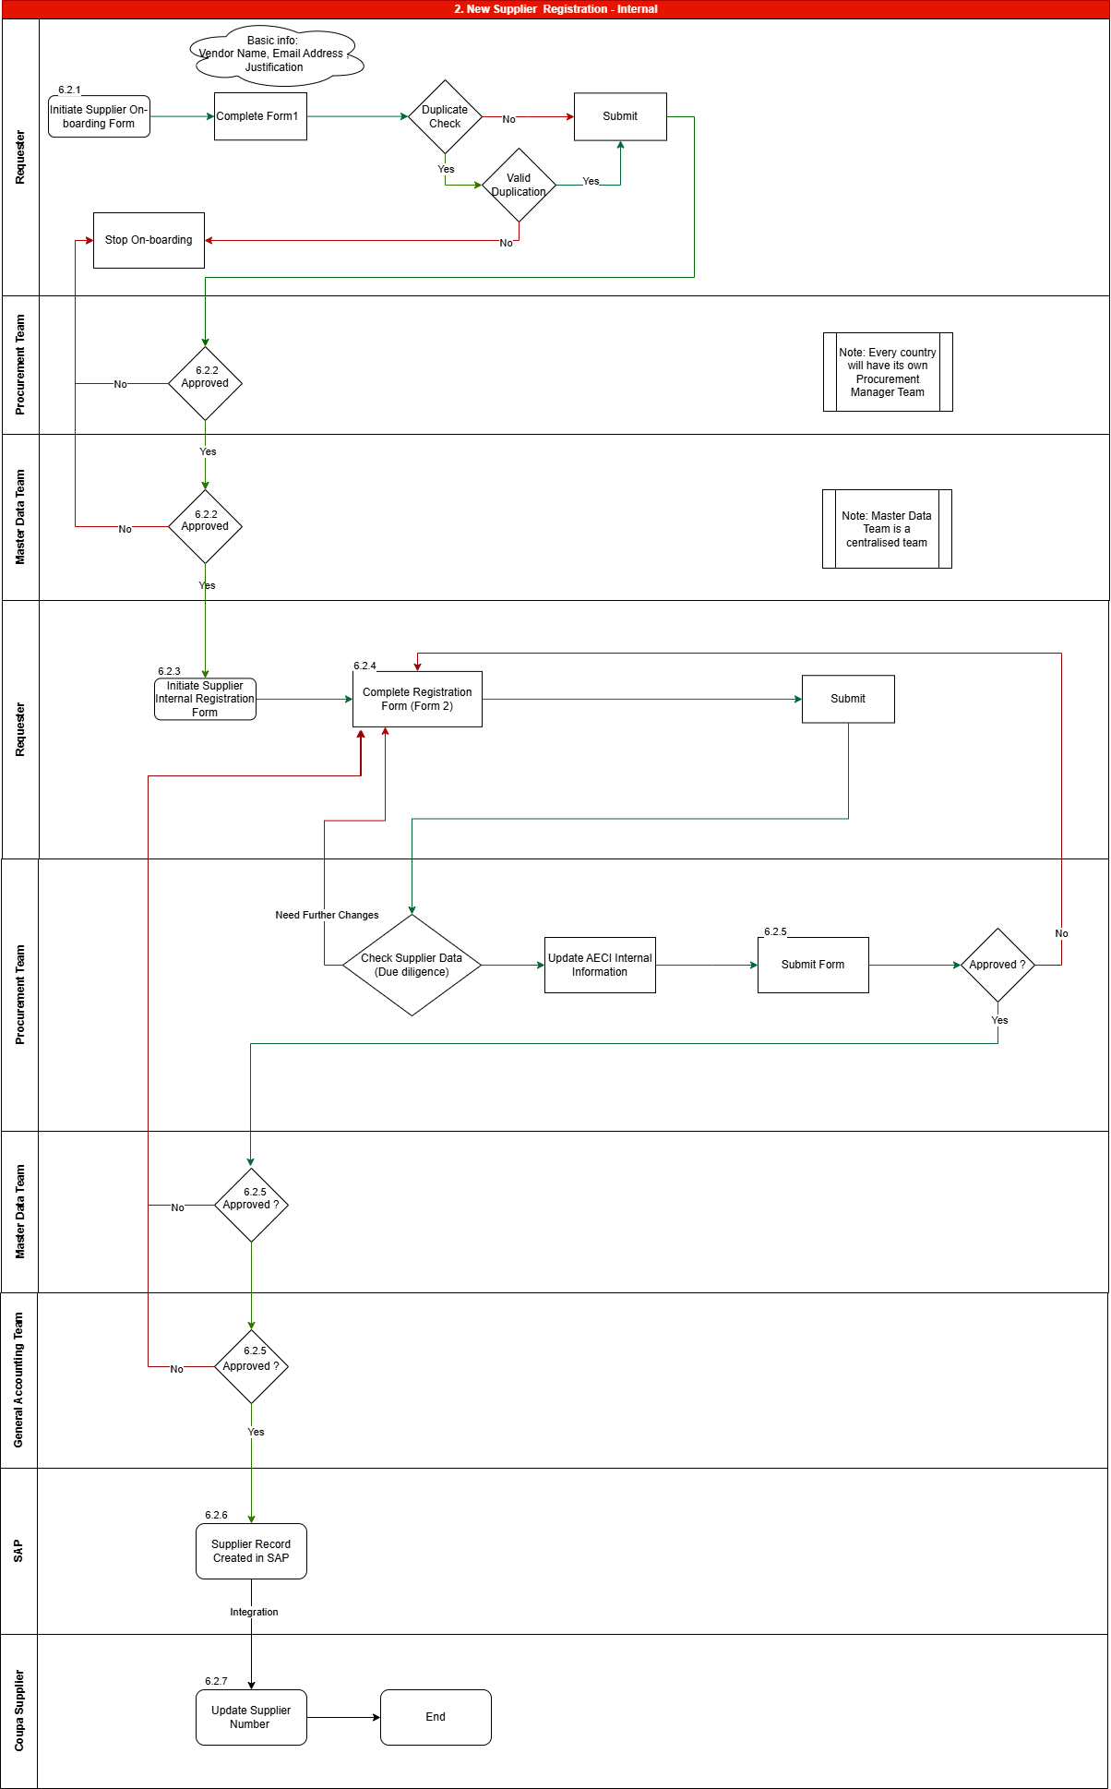
6.2 New Supplier Registration – Internal registration

Activity ID | Activity Description | Detailed Description
6.2.1 | Internal Supplier Request | The internal supplier onboarding process is initiated by the requester through the New Supplier Internal Request form, accessible via the “New Supplier Internal Request” button under Explore Shortcuts on the Home screen. The requester must provide all required supplier details in the form. Once submitted, the system automatically validates the information, checking for duplicate entries based on the supplier name, tax ID and email ID, and highlights any missing or incomplete fields for correction before final submission.
6.2.2 | Internal Request Approvals | Once the New Supplier Internal Request Form is submitted, the approval process is automatically triggered based on the predefined workflow, typically involving:  - Procurement Team  - Master Data Team  In case of rejection, the system prompts approvers to provide rejection comments. These comments are shared with the requester, enabling them to review the feedback and resubmit the request after making the necessary corrections.
6.2.3 | Coupa auto triggers the Internal Onboarding form | Once the New Supplier Internal Request Form is approved, Coupa automatically triggers the Internal Supplier Onboarding Form, which is sent to the requester. This form is designed to capture all necessary supplier details required for onboarding, ensuring data accuracy, completeness, and secure integration into the procurement system.
6.2.4 | Requester fills up the Internal Onboarding form | The Internal Supplier Onboarding Form is triggered via email and Coupa notifications to the requester. The form includes additional information that must be completed to successfully onboard a supplier for AECI. Once all mandatory fields are filled in, the requester can proceed to submit the form for processing.
6.2.5 | Internal Supplier Onboarding Form Approvals | Once the Internal Onboarding Form is submitted by the requester, it enters the approval workflow.  Procurement Team – The first step involves validation by the Procurement Team, who reviews the submitted information for accuracy and completeness, including supplier data due diligence. The Procurement Manager updates the onboarding form as needed and completes the internal review section. Once validated, the request is forwarded to the Master Data Team for further processing.  If the request is rejected, the system prompts the approver to provide rejection comments. These comments are shared with the requester, who can review the feedback and resubmit the request with the necessary corrections.  Master Data Team – The Master Data Team reviews and validates the supplier’s details. Upon satisfactory review, they approve and submit the form. If corrections are required, the team rejects the form with comments, allowing the requester to update and resubmit the information.  Approval Outcomes:  - Approved – A supplier record is created in Coupa.  - Rejected – The system records the rejection comments and notifies the requester, who can correct and resubmit the request.  General Accounting Team – The General Accounting Team reviews and validates the supplier’s banking details. Upon satisfactory review, they approve and submit the form. If corrections are required, the team rejects the form with comments, allowing the requester to update and resubmit the information.  Approval Outcomes:  - Approved – A supplier record is created in Coupa.  - Rejected – The system records the rejection comments and notifies the requester, who can correct and resubmit the request.
6.2.6 | Integration from Coupa SIM to SAP to create a Supplier record in SAP | Supplier details are seamlessly transferred from Coupa Supplier Information Management (SIM) to SAP. During this integration, a new supplier record is automatically created in SAP, and a unique supplier number is assigned.  Once the supplier is successfully created in SAP, the system will wait for the supplier (vendor) record in SAP to be reviewed by the Master Data team and released. Until the supplier is released in SAP, the corresponding supplier records will be kept inactive in Coupa for usage.
6.2.7 | Integration from SAP to Coupa to Activate the Supplier in Coupa | Once the supplier is successfully created in SAP, the supplier number and other key details are automatically synchronized with the corresponding supplier record in Coupa. As part of this integration, the supplier’s status in Coupa is updated to “Active”, indicating that the supplier has been fully onboarded and is ready for use within the procurement system.

Update Vendor – External
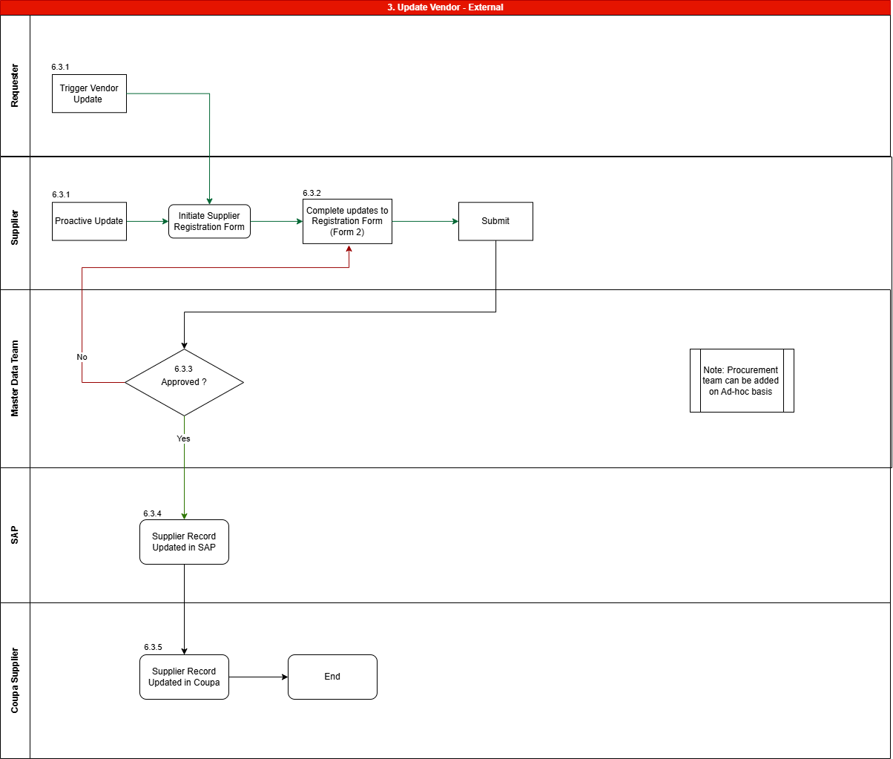
6.3 Update Vendor – External Flow

Activity ID | Activity Description | Detailed Description
6.3.1 | Update Vendor –External | The update process for an existing external supplier can be initiated in either of the following ways:  - The requester initiates the update by sending the Supplier Registration Form to the supplier for completion.  - The supplier proactively updates their Supplier Registration Form through the Coupa Supplier Portal (CSP).
6.3.2 | Supplier On-Boarding Form Update | The supplier updates the form with the necessary changes and submits it to AECI for review.  Note: The supplier should update only the fields that require modification and attach relevant supporting documents, if applicable.  This process ensures that the latest supplier information is accurately captured in the system.
6.3.3 | Supplier On-Boarding Form Update Approvals | Once the Supplier Onboarding Form is submitted, the approval process is automatically initiated according to the predefined workflow:  - Master Data Team  If corrections are required, the approver will reject the form with comments, which will be sent back to the supplier for the necessary updates.  Approval Outcomes:  - Approved - The supplier record is updated in Coupa.  - Rejected - The system prompts the approver to provide rejection comments. These comments are shared with the supplier, who can review the feedback and resubmit the request with the corrected information.  Note: Approvers are required to validate only the fields that the supplier has requested to update.
6.3.4 | Integration from Coupa SIM to SAP to update SAP Supplier record | Supplier details are seamlessly transferred from Coupa Supplier Information Management (SIM) to SAP. During this integration, the supplier record is automatically updated in SAP.  Once the supplier is successfully updated in SAP, the system will wait for the supplier (vendor) record in SAP to be reviewed by the Master Data team and release the updates. Until the supplier updates are released in SAP, the corresponding supplier records will be kept inactive in Coupa for usage.
6.3.5 | Integration from SAP to Coupa to update the Coupa Supplier record | Once the supplier is successfully updated in SAP, the updated supplier details are automatically synchronized with the corresponding supplier record in Coupa.

Update Vendor – Internal
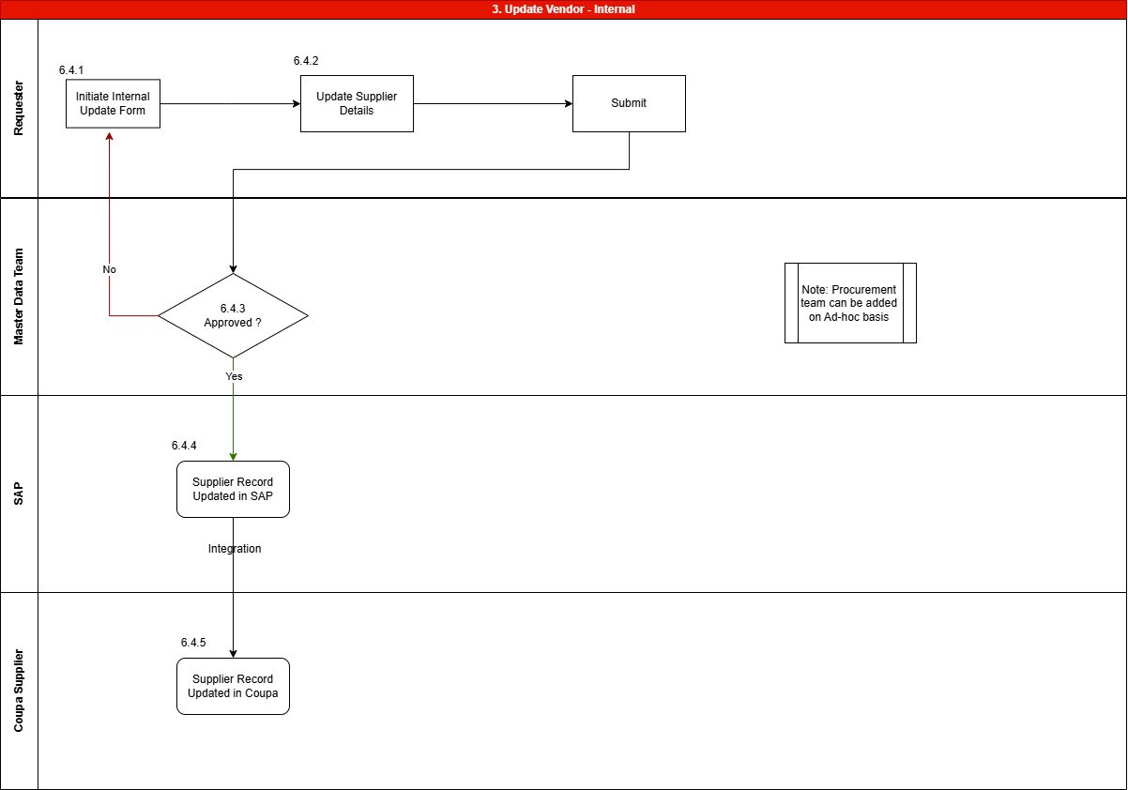6.4 Update Vendor – Internal Flow

Activity ID | Activity Description | Detailed Description
6.4.1 | Update Vendor –Internal | The update process for an internal existing vendor can be initiated by the requester.
6.4.2 | Supplier On-Boarding Form Update | The requester updates the Supplier Onboarding Form with the necessary vendor information and submits it for review.  Note: The requester should update only the fields that require modification and attach relevant supporting documents, if applicable.  This ensures that the latest details are accurately captured in the system.
6.4.3 | Supplier On-Boarding Form Update Approvals | Once the Supplier Onboarding Form is submitted, the approval process is automatically initiated according to the predefined workflow:  - Master Data Team  If corrections are required, the approver will reject the form with comments, which will be returned to the requester for necessary changes.  Approved: The supplier record is updated in Coupa.  Rejected: The system prompts the approver to provide rejection comments. These comments are shared with the requester, who can review and resubmit the request with the corrected information.  Note: Approvers are required to validate only the fields that have been updated by the requester.
6.4.4 | Integration from Coupa SIM to SAP to update the Supplier record in SAP | Supplier details are seamlessly transferred from Coupa Supplier Information Management (SIM) to SAP. During this integration, the updated supplier record is automatically created in SAP.  Once the supplier is successfully updated in SAP, the system will wait for the supplier (vendor) record in SAP to be reviewed by the Master Data team and release the updates. Until the supplier updates are released in SAP, the corresponding supplier records will be kept inactive in Coupa for usage.
6.4.5 | Integration from SAP to Coupa to update the Supplier record in Coupa | Once the supplier is successfully updated in SAP, the updated supplier details are automatically synchronized with the corresponding supplier record in Coupa.

Update Vendor – Status (Purchase block/ Payment Block/ Deactivate/ Reactivate)
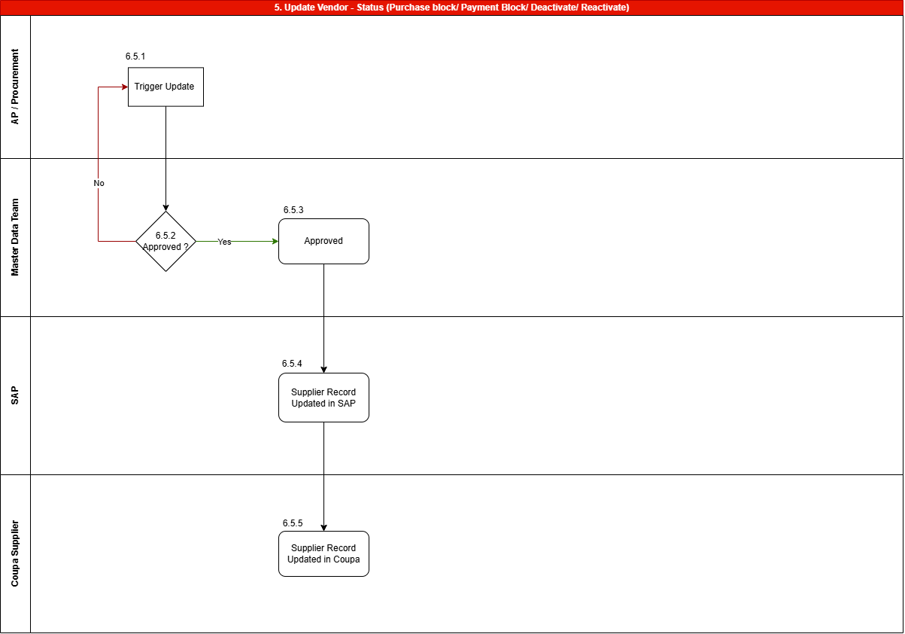
6.5 Update Vendor – Status
Activity ID | Activity Description | Detailed Description
6.5.1 | Update Vendor – Status | The process begins when the Accounts Payable (AP) Team or Procurement Team identifies the need to update a vendor’s status.
6.5.2 | Update Vendor | The update may involve actions such as placing a purchase block, payment block, deactivation, or reactivation. The responsible team initiates the update request in Coupa.
6.5.3 | Update Request Approvals | Once the update request is initiated, it is routed to the Master Data Team for approval. The Master Data Team reviews the nature and necessity of the status update.  - If approved, the request proceeds for execution.  - If rejected, the system prompts the approver to provide rejection comments, which are shared with the AP/Procurement Team. The process is stopped, and the requester is notified via email to halt the update.  The requester can review the feedback, make necessary corrections, and resubmit the request if required.
6.5.4 | Integration from Coupa SIM to SAP | Once approved, supplier details are seamlessly transferred from Coupa Supplier Information Management (SIM) to SAP. During this integration, the supplier record is updated to reflect the current and approved status.  Once the supplier is successfully updated in SAP, the system will wait for the supplier (vendor) record in SAP to be reviewed by the Master Data team and release the updates. Until the supplier updates are released in SAP, the corresponding supplier records will be kept inactive in Coupa for usage.
6.5.5 | Integration from SAP to Coupa | The process is considered complete once the approved changes are successfully updated in Coupa. All watchers and stakeholders are informed through system-generated notifications, ensuring transparency, audit readiness, and accountability.
Note | Supplier Bulk Maintenance | Suppliers can be bulk deactivated in both SAP and Coupa. When the deactivation is initiated in SAP through a central vendor block, the SAP–Coupa integration automatically sets the corresponding supplier records in Coupa to an inactive status. However, the Supplier Information Management (SIM) records in Coupa are not updated through this integration and may remain active. This does not have any functional impact on downstream procurement or payment processes, as purchasing and invoicing are controlled by the Coupa supplier status.

SUPPLIER EXTEND
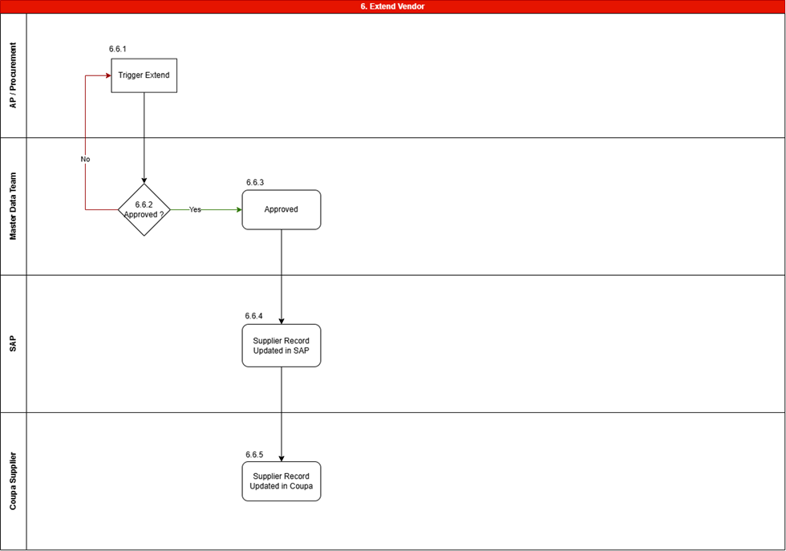
6.6 Supplier Extend

Activity ID | Activity Description | Detailed Description
6.6.1 | Extend Vendor Triggering | The process begins when user identifies the need to extend a vendor to other companies.
6.6.2 | Extend Vendor | The extension will involve adding Purchasing Org along with other relevant fields.
6.6.3 | Extend Request Approvals | Once the extension request is initiated, it is routed to the Master Data Team for approval. The team reviews the nature and necessity of the extension.  - If approved, the request proceeds for execution.  - If rejected, the system prompts the approver to provide rejection comments, which are shared with the user. The process is stopped, and the user is notified via email to halt the extension.  The user can review the feedback, make necessary corrections, and resubmit the request if required.
6.6.4 | Integration from Coupa SIM to SAP | Once approved, supplier details are seamlessly transferred from Coupa Supplier Information Management (SIM) to SAP. During this integration, the supplier record is updated to reflect the current and approved status.  Once the supplier is successfully updated in SAP, the system will automatically release the updates in SAP.
6.6.5 | Integration from SAP to Coupa | The process is considered complete once the approved extensions are successfully updated in Coupa. All watchers and stakeholders are informed through system-generated notifications, ensuring transparency, audit readiness, and accountability.

New Supplier Registration – One Time Vendor
The One-Time Vendor (OTV) process is designed for suppliers engaged for a single or non-recurring transaction. It enables faster vendor creation with a simplified approval flow and reduced data requirements, while still ensuring basic compliance and procurement controls.
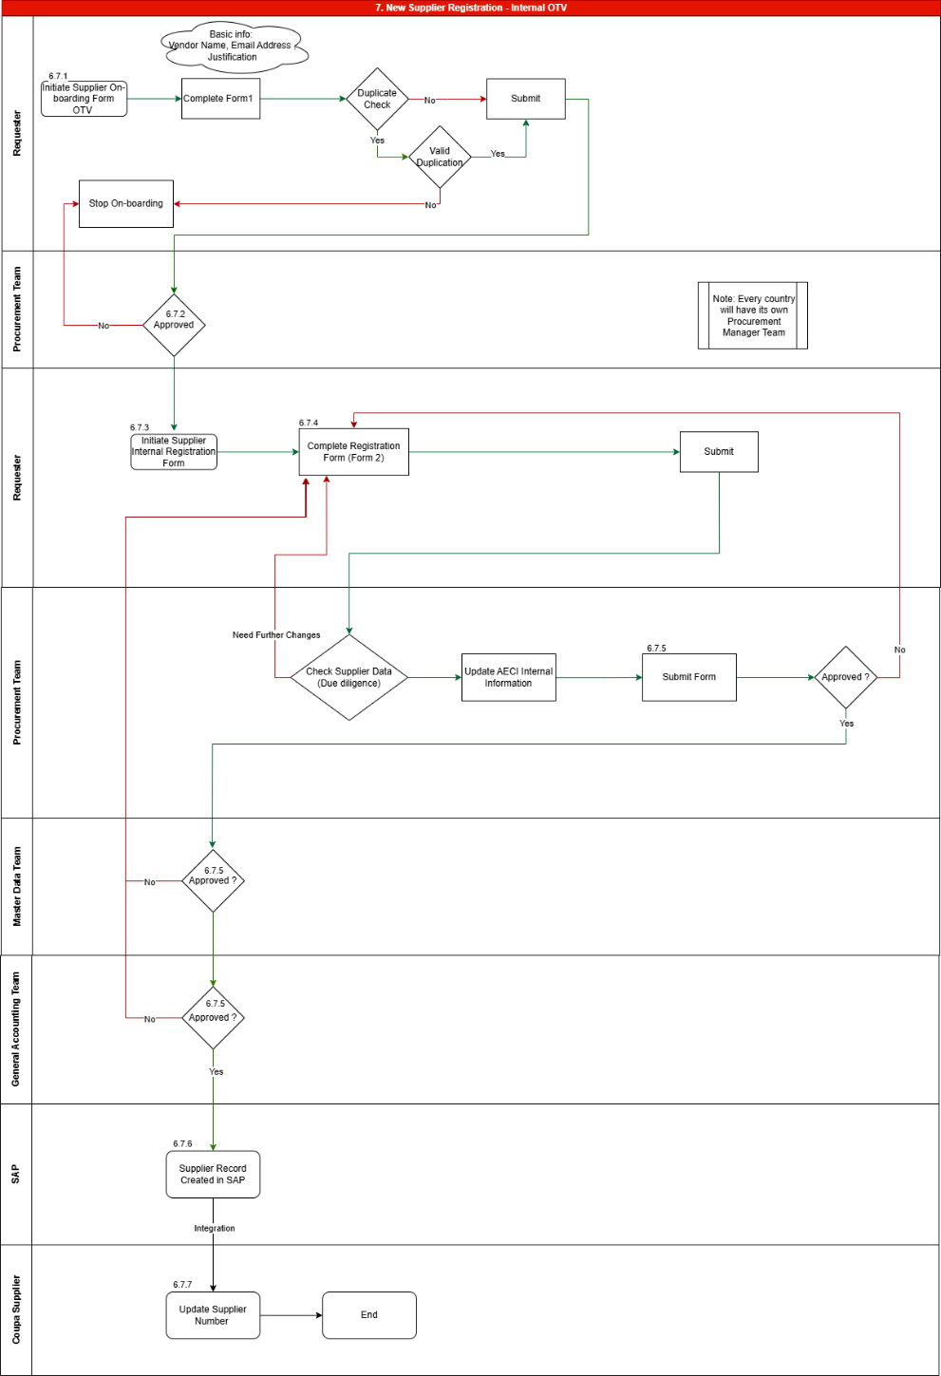
6.7 One-Time Vendor Process
New Supplier Registration – Internal OTV follows the same overall structure as New Supplier Onboarding – Internal, with a few key differences. For detailed steps, please refer to Section 6.2.
There is no change to the Internal Request Form (Form 1) in terms of fields or content. However, the approval workflow is updated. Under the OTV process, the request will be approved only by the Procurement Team, while Form 2 approval remains the same as outlined in Section 6.2.
The main changes apply to the Supplier Onboarding Form (Form 2).
Section 1 (General Vendor Information): the fields Secondary Contact, Personal Services, and Labour Broker are removed.
Section 2 (Attachments): Several documents including Banking Master Data and IRP 30 Certificate are removed to ensure quick onboarding on the vendor.
Section 3 (Banking Information): The Banking Confirmation Documentation is relocated to this section,while the remaining fields of Section 3 remains unchanged.
Section 4 (Declaration): This is eliminated as AECI users will not provide declaration on behalf of OTVs.
Section 5 (AECI Internal Use Only): No changes in fields.
Overall, the OTV process retains the existing structure while streamlining approvals and reducing data capture and documentation requirements.

Coupa SUPPLIER STATUS
Coupa uses different status labels to help users quickly see the status of each supplier.
Supplier Record Status
Status | Description
Active | The Supplier Record will be set to Active through integration from SAP to Coupa.
Onboarding | Once the Internal Onboarding form has been Approved, the Supplier Record is set to Onboarding.
Inactive | Inactive Suppliers remain in the system; however, these Suppliers cannot be used for Sourcing Events.
Coupa Supplier Portal (CSP) Status (STANDARD STATUS OF CSP)
In the Suppliers table, use the Supplier Portal Status column to see CSP statuses.
Status | Description
Invited | The supplier has been invited to the CSP but has not completed the linking process.
'Draft' or 'Inactive' Status | The supplier record is in Draft or Inactive status until it has been integrated to SAP and will be linked only when it is in Active status.
Name and Email Missing | The supplier record is missing the supplier contact's name and email. You cannot send a CSP invite until this information is complete.
Linked | The supplier is linked to you on the CSP, and you can transact with them using the CSP.
Not Linked | The supplier is not linked to you on the CSP. You can send them an invite in the Actions column of the Suppliers table.

KEY DECISIONS MADE AND EXCEPTIONS
Supplier Management
All the key decisions made by AECI team during the Requirement Gathering workshops and the sessions help offline thereafter are covered below with their status.
S. No. | Key decisions
1 | Suppliers will be created at Company Code and Purchase Org levell and can be extended to other companies.
2 | Vendor Account Group dropdown in SAP that drives spend analytics in the as-is process - To-be will be replaced by the commodity trees in Coupa.
3 | All AECI business units require a Swift code except SA
4 | Suppliers without connectivity, municipalities and universities - Internal Supplier Update Form process will follow.
5 | The supplier information screening performed by the Master Data Team and the General Accounting Team for various inputs from the suppliers will be carried out outside Coupa as per the existing process.
6 | The decision to enable the supplier for purchase in Coupa before the corresponding record is released in SAP has been confirmed and there will be a manual release of supplier in SAP.
7 | One time vendor process will be configured as a separate form for onboarding as outlined in Section 6.7.

GEOGRAPHICAL PROCESS DEVIATIONS

Process deviations
With respect to the supplier onboarding and supplier management process, the To-Be process will be standard and applicable to all the geographies, apart from a few distinctions for Australia in the approval workflows. These distinctions are already highlighted in the above-mentioned workflow descriptions.

Information (Field REQUIRements) Deviations during onboarding
There are few differences with respect to the information requested from suppliers at the time of onboarding. These inputs are based on the local guidelines and requirements implied or required as per the legal requirements.
The field level requirements highlighted by each geography is captured in the document stored at the below path. Please access the document and review the field requirements as per your respective geography. In case there is any change required, please let us know as part of the feedback for this document.
Vendor Onboarding Form Information.xlsx
Kindly note that, based on the geographical requirements outlined in the above document, the visibility of the inputs required will be controlled based on the country selected for the supplier.

List of all attachments required across geographies
The list of documents that are required to be completed or attached by vendors during the onboarding and update processes is detailed in the Excel sheet referenced below. This document outlines the mandatory and conditional attachments applicable across different geographies, based on local statutory, regulatory, and business requirements.
Vendors are responsible for ensuring that all required documentation is accurate, complete, and up to date to facilitate timely review and approval.

Country Specific Attachments.xlsx

Language Requirements
Coupa supports the auto-translation of the standard information on the user interface (for internal users as well as suppliers) for the following languages.
For any custom information added in the system (custom fields, custom messages on the forms, NDA attachments etc), the respective geography’s subject matter experts will need to provide us with the necessary translation, which can be configured in the system for local language requirements.
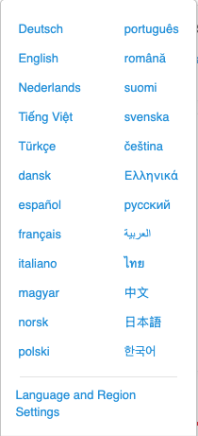

UAT Scenarios
S. No. | UAT Scenario | Expected Outcome
1 | New Supplier Request – External (Requester) | System validates mandatory fields and successfully submits the request
2 | Duplicate Supplier Validation | System identifies duplicate Supplier Name, Email ID, or Tax Details and prevents submission
3 | New Supplier Request Approval (Procurement Team & Master Data Team) | Approval workflow completes and External Onboarding Form is triggered
4 | External Supplier Invitation | Supplier receives onboarding email with secure CSP/OTP access
5 | External Onboarding via Coupa Supplier Portal (Supplier) | Supplier registers on CSP and submits onboarding form successfully
6 | External Onboarding via OTP (Supplier) | Supplier completes onboarding using OTP without CSP registration
7 | Mandatory Field Validation (Supplier Form) | System displays validation errors and blocks submission
8 | Mandatory Attachment Validation | Required documents are uploaded and validated successfully
9 | External Onboarding Approval – Procurement Team | Procurement Team validates details and forwards request
10 | External Onboarding Rejection with Comments | Supplier receives rejection comments and can resubmit
11 | Banking Details Approval – General Accounting Team | Banking details are validated and approved
12 | Supplier Record Creation in Coupa | Supplier record is created with status “Onboarding”
13 | Supplier Validation – Master Data Team | Supplier details are validated and approved
14 | New Supplier Request – Internal (Requester) | Internal supplier onboarding process is initiated
15 | Internal Onboarding Approval (Procurement, Master Data, General Accounting) | Supplier record is created after all approvals
16 | Supplier Update – External (via CSP) | Supplier updates are submitted and routed to Master Data Team
17 | Supplier Update – Internal (Requester) | Internal update request is approved and processed
18 | Supplier Update Rejection (Master Data Team) | Rejection comments are shared and resubmission allowed
19 | Purchase Block – Supplier Status Update | Supplier is blocked for purchase transactions
20 | Payment Block – Supplier Status Update | Supplier is blocked for payments
21 | Supplier Deactivation | Supplier is unavailable for sourcing and transactions
22 | Supplier Reactivation | Supplier status updates to Active
23 | CSP Status – Invited | Supplier CSP status shows “Invited”
24 | CSP Status – Linked | Supplier CSP status updates to “Linked”
25 | Notification & Audit Trail Validation | All actions generate notifications and audit logs

ACKNOWLEDGMENT AND SIGNATURE

Process Owners
No. | Author/Owner | Version | Email
1.
2.

Document Reviewers
No. | Author/ Owner | Division | Signature
1.
2.
3.
4.

Signatures
The undersigned do hereby agree to the information mentioned in the above pages of this document.
AECI | AECI
Signature:  Name :  Title :  Date : | Signature:  Name :  Title :  Date :

